Task on RDS
- Create MariaDB DB on EC2.

Step 1: Connect to EC2
Use SSH to connect:
ssh -i CT-keypair.pem ec2-user@your-ec2-172.31.5.154

Step 2: Install MariaDB
Run:
sudo dnf update -y
sudo dnf install mariadb105-server -y

Step 3: Start and Enable MariaDB
sudo systemctl start mariadb
sudo systemctl enable mariadb
Check status:
sudo systemctl status mariadb

Step 4: Secure MariaDB (Important)
Run:
sudo mysql_secure_installation
Follow prompts:
- Set root password → YES
- Remove anonymous users → YES
- Disallow root login remotely → YES
- Remove test DB → YES
- Reload privileges → YES

Step 5: Login to MariaDB
mysql -u root -p
Enter your root password.

Step 6: Create Database
Inside MariaDB shell:
CREATE DATABASE mydb;
Verify:
SHOW DATABASES;

Step 7: Create User (Recommended)
CREATE USER 'myuser'@'localhost' IDENTIFIED BY 'mypassword';

Step 8: Grant Permissions
GRANT ALL PRIVILEGES ON mydb.* TO 'myuser'@'localhost';
FLUSH PRIVILEGES;

Step 9: Exit
EXIT;

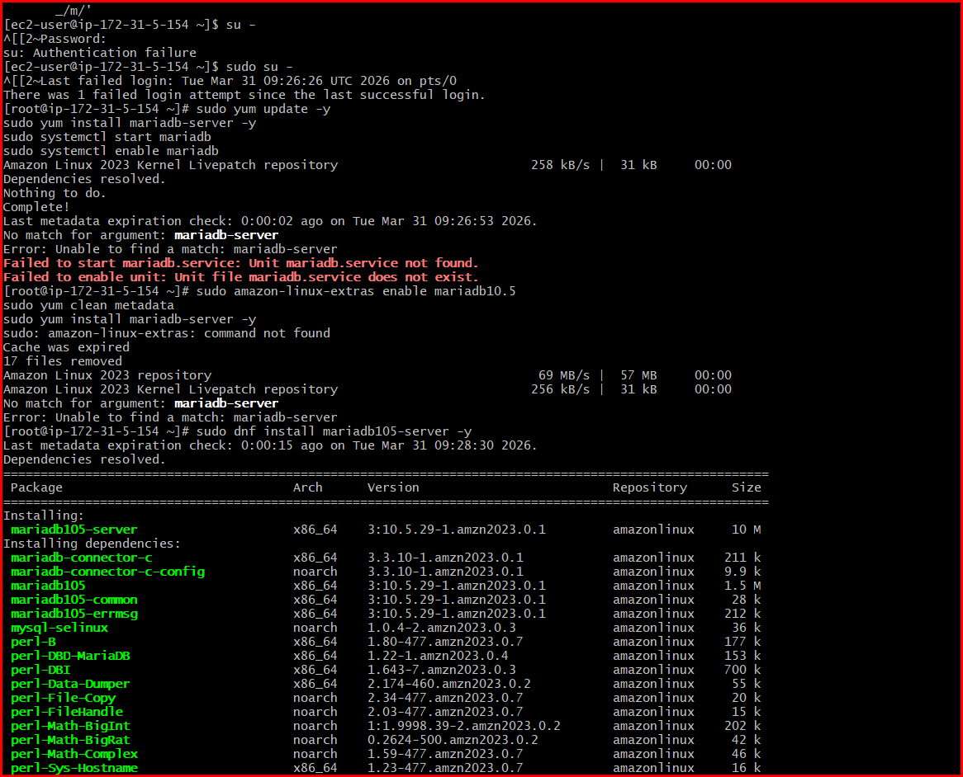
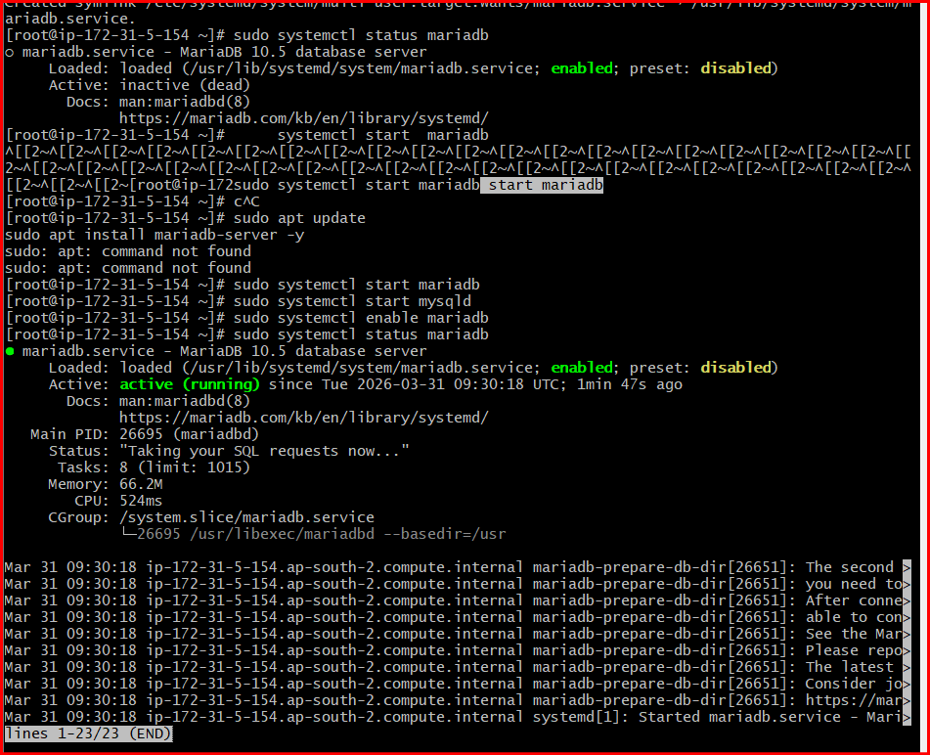

- Insert some dummy data.

Step 1: Create Database
CREATE DATABASE mydb;

Step 2: Use Database
USE mydb;

Step 3: Create Table
CREATE TABLE employees (
id INT AUTO_INCREMENT PRIMARY KEY,
name VARCHAR(50),
email VARCHAR(100),
salary INT
);

Step 4: Insert Your Data
INSERT INTO employees (name, email, salary) VALUES
('Billal', 'billa1@gmail.com', 50000),
('Rahul', 'rahul@gmail.com', 60000),
('Amit', 'amit@gmail.com', 55000),
('Sara', 'sara@gmail.com', 65000);

Step 5: Verify Data
SELECT * FROM employees;
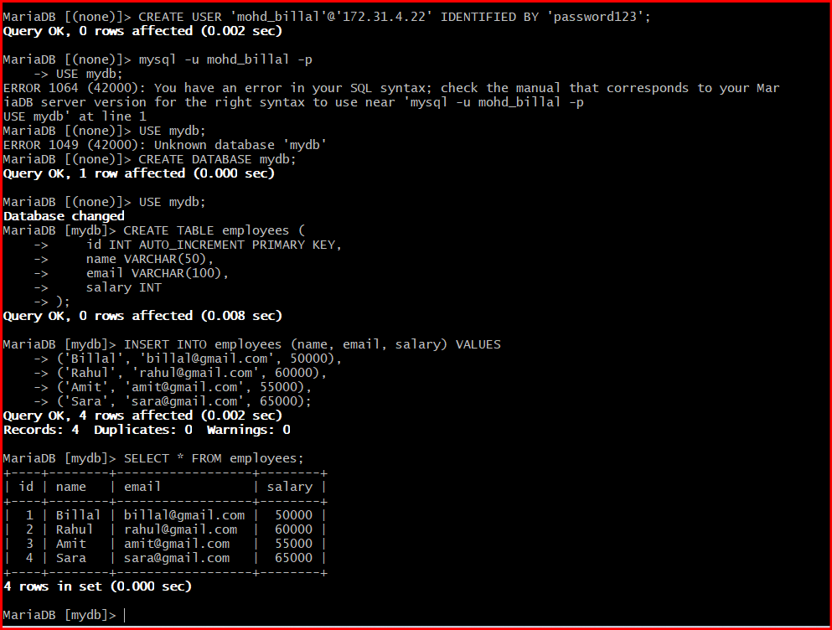

3.Take the backup of dummy data on EC2.

Step 1: Create Database
CREATE DATABASE testdb;

Step 2: Use Database
USE testdb;

Step 3: Create Table (as per your backup)
CREATE TABLE employees (
id INT NOT NULL AUTO_INCREMENT,
name VARCHAR(50) DEFAULT NULL,
role VARCHAR(50) DEFAULT NULL,
PRIMARY KEY (id)
);

Step 4: Insert Your Data
INSERT INTO employees VALUES
(1,'John','Dev'),
(2,'Alice','Tester'),
(3,'Bob','Manager');

Step 5: Verify Data
SELECT * FROM employees;

Step 6: Take Backup (Already Done by You ✅)
mysqldump -u root -p testdb > testdb.sql

Step 7: Restore This Backup (Important for Next Steps like RDS)
If you want to restore this same data anywhere:
mysql -u root -p testdb < testdb.sql

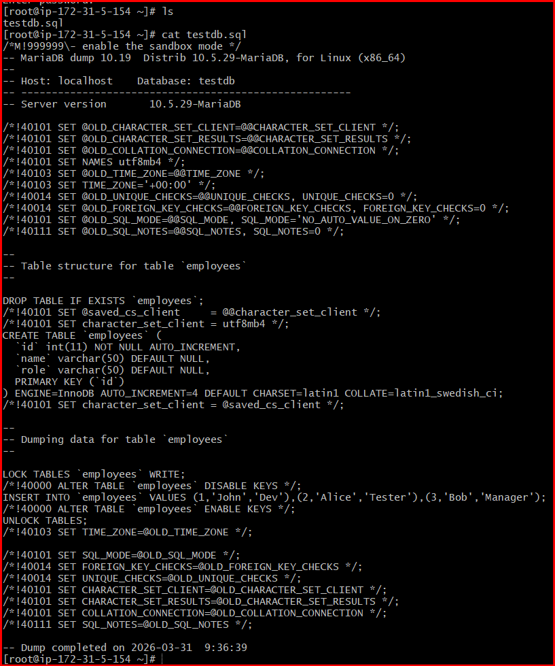

4.Launch MariaDB RDS instance.

Step 1: Open RDS Console
- Login to AWS Console
- Search for RDS
- Click Create database

Step 2: Choose Database Creation Method
- Select Standard create

Step 3: Select Engine
- Choose MariaDB

Step 4: Choose Version
- Select latest stable version (default is fine)

Step 5: Templates
- Choose:
  - Free tier (for practice)
  - or Dev/Test

Step 6: Settings
- DB instance identifier → mariadb-db
- Master username → admin
- Master password → create your password

Step 7: Instance Configuration
- DB instance class → db.t3.micro (free tier)

Step 8: Storage
- Storage type → General Purpose (gp2/gp3)
- Allocated storage → 20 GB (default)

Step 9: Connectivity
- VPC → default (or your custom VPC)
- Public access → Yes (for testing)
- VPC security group → allow MySQL/MariaDB (port 3306)

Step 10: Additional Configuration
- Initial database name → testdb ✅ (important for your backup)
- Backup → enable automatic backups

Step 11: Create Database
- Click Create database
- Wait until status = Available

Step 12: Get Endpoint
- Go to your DB → copy Endpoint

Step 13: Connect from EC2
mysql -h <rds-endpoint> -u admin -p

Step 14: Verify Database
SHOW DATABASES;
You should see:
testdb

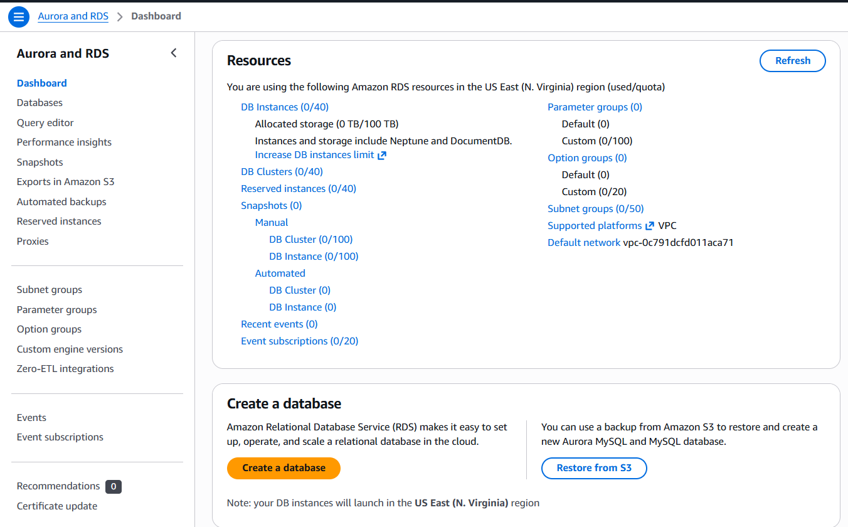

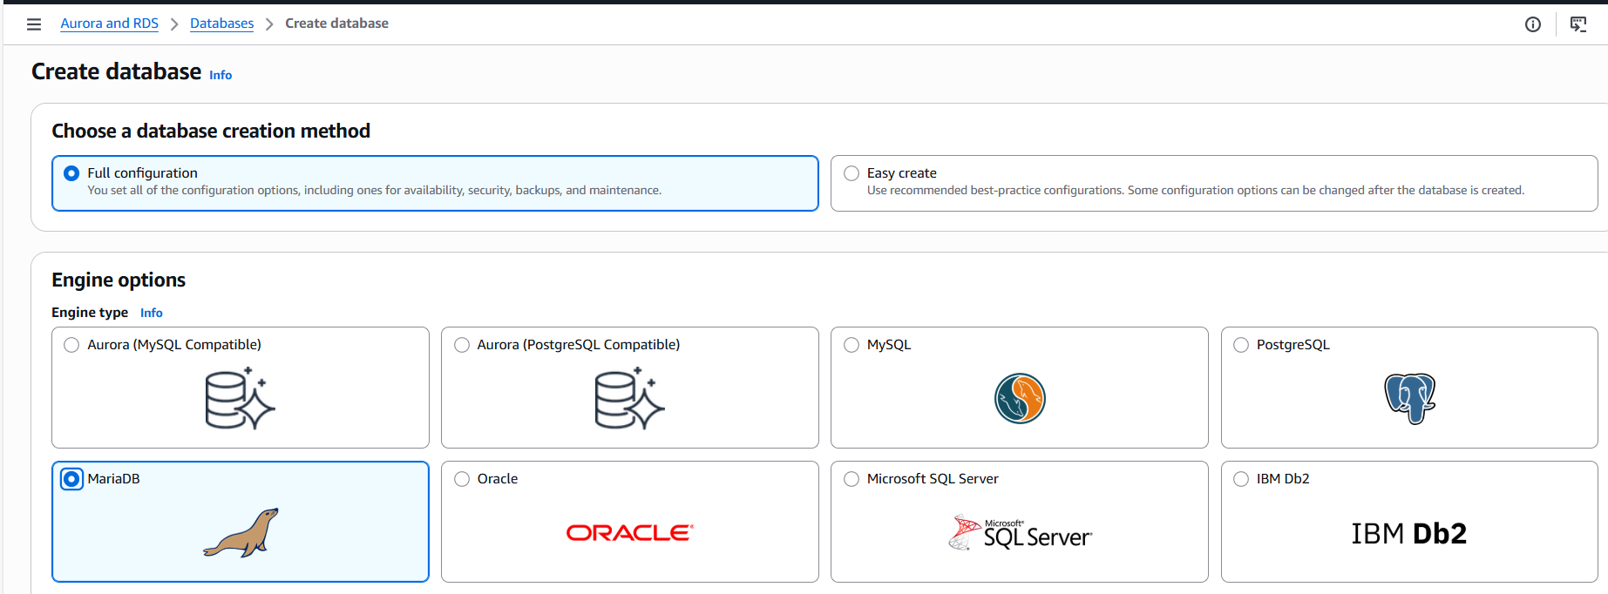
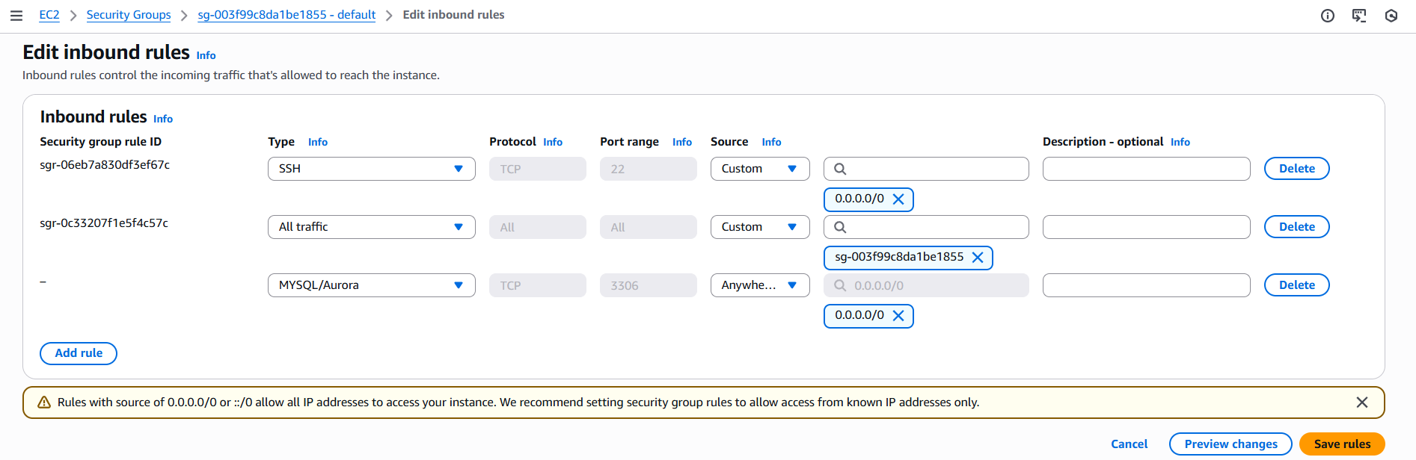
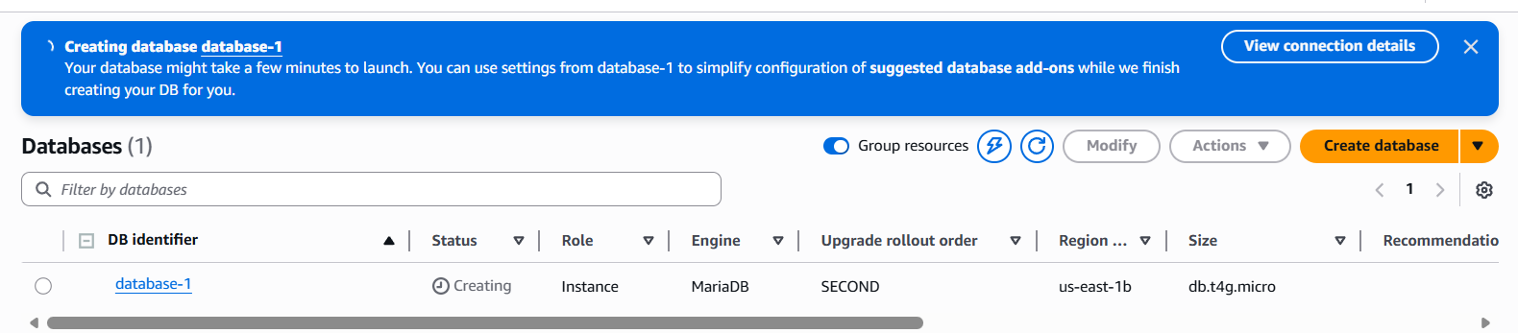
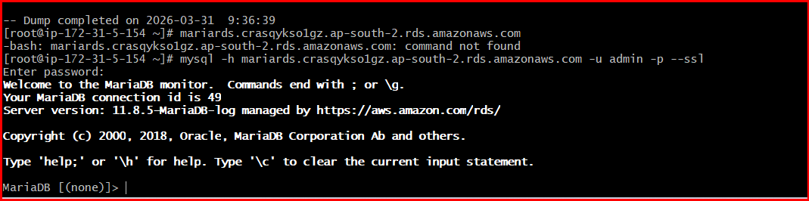

5.Migrate database from EC2 to RDS.

Step 1: Ensure Prerequisites
- RDS MariaDB instance is Available
- You have endpoint, username (admin), password
- testdb.sql is present on EC2

Step 2: Check Backup File on EC2
ls

Step 3: Test Connection to RDS
mysql -h <rds-endpoint> -u admin -p

Step 4: Create Database in RDS (if not created)
CREATE DATABASE testdb;
EXIT;

Step 5: Restore Backup to RDS
mysql -h <rds-endpoint> -u admin -p testdb < testdb.sql

Step 6: Verify Migration
mysql -h <rds-endpoint> -u admin -p
USE testdb;
SELECT * FROM employees;

Expected Output
- John → Dev
- Alice → Tester
- Bob → Manager

Common Errors & Fixes
Access denied
Check username/password
Connection timeout
Check security group → allow port 3306
Database not found
CREATE DATABASE testdb;

Migration Completed
Your data is now moved from EC2 to RDS
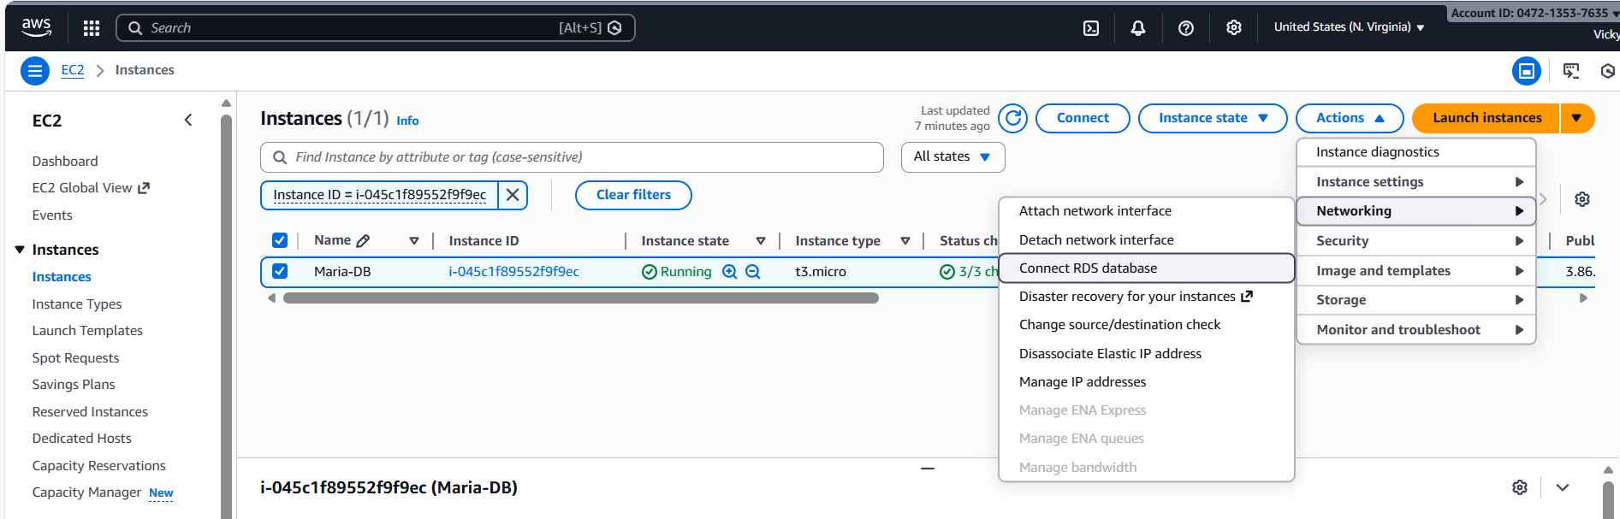
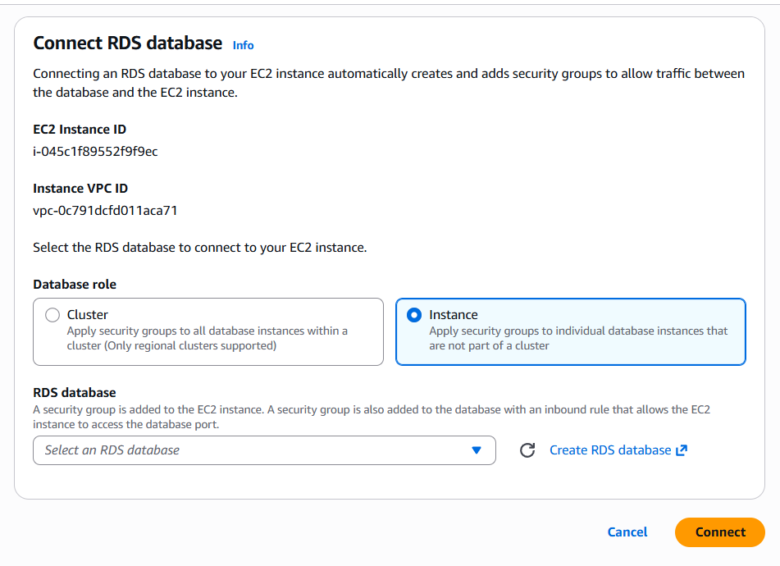
6. Install MySQL DB on EC2.

Step 1: Connect to EC2
ssh -i your-key.pem ec2-user@<your-ec2-public-ip>

Step 2: Update Packages
sudo dnf update -y

Step 3: Install MySQL Server
sudo dnf install mysql-server -y

Step 4: Start MySQL Service
sudo systemctl start mysqld

Step 5: Enable MySQL on Boot
sudo systemctl enable mysqld

Step 6: Check Status
sudo systemctl status mysqld

Step 7: Secure MySQL Installation
sudo mysql_secure_installation
- Set root password
- Remove anonymous users → Yes
- Disallow root login remotely → Yes
- Remove test database → Yes

Step 8: Login to MySQL
mysql -u root -p

Step 9: Verify Installation
SHOW DATABASES;

Common Issues
Command not found
Install again using dnf install mysql-server
Service not starting
sudo systemctl restart mysqld
Access denied
Make sure correct password is used

Now MySQL is successfully installed on EC2
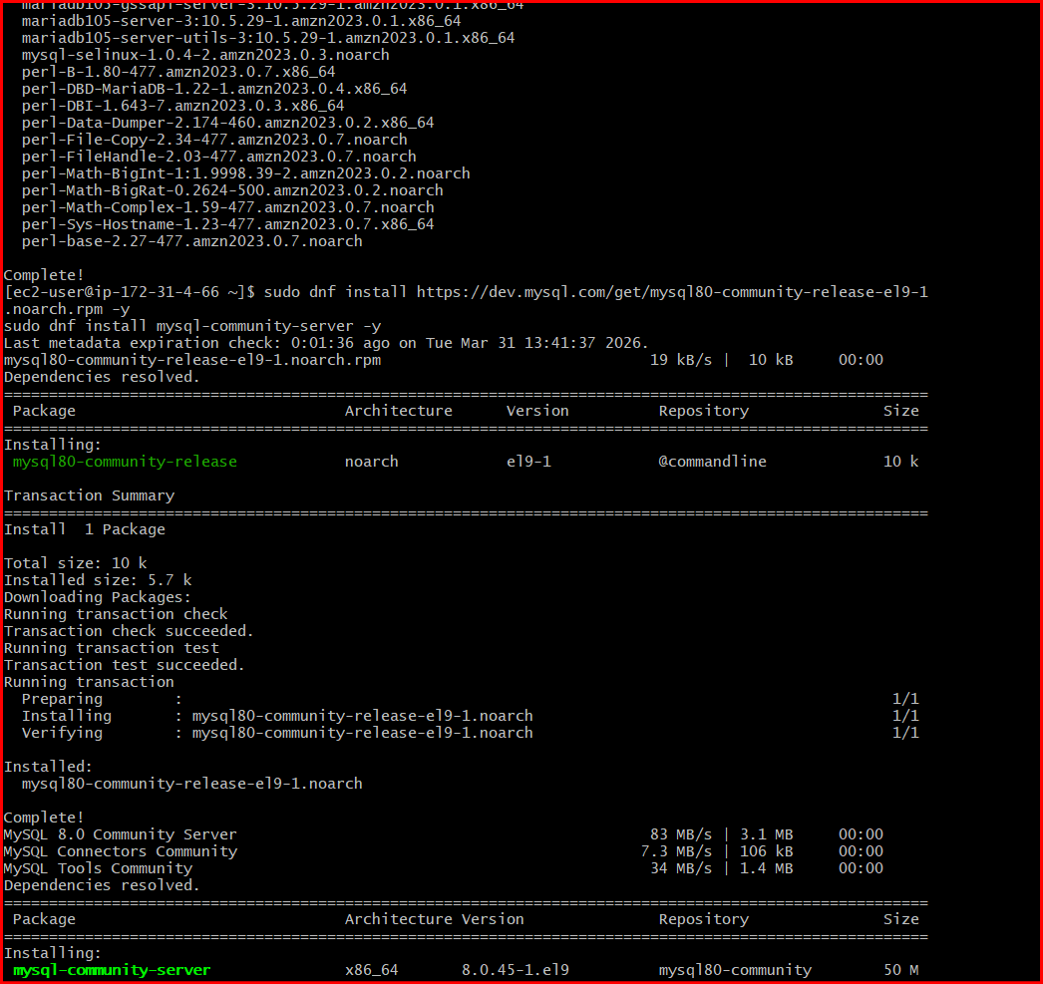


7. Launch MySQL RDS image.

Step 1: Open RDS Console
Login to AWS → search RDS → click Create database

Step 2: Choose Creation Method
Select Standard create

Step 3: Select Engine
Choose MySQL

Step 4: Select Version
Choose latest version (default is fine)

Step 5: Choose Template
- Free tier (for practice)
- or Dev/Test

Step 6: Settings
- DB instance identifier → mysql-db
- Master username → admin
- Master password → set your password

Step 7: Instance Configuration
- DB instance class → db.t3.micro (free tier)

Step 8: Storage
- Storage type → gp2 / gp3
- Allocated storage → 20 GB

Step 9: Connectivity
- VPC → default
- Public access → Yes (for testing)
- Security group → allow port 3306

Step 10: Additional Configuration
- Initial database name → testdb
- Enable automated backups

Step 11: Create Database
Click Create database
Wait until status = Available

Step 12: Get Endpoint
Open DB → copy Endpoint

Step 13: Connect from EC2
mysql -h <rds-endpoint> -u admin -p

Step 14: Verify
SHOW DATABASES;

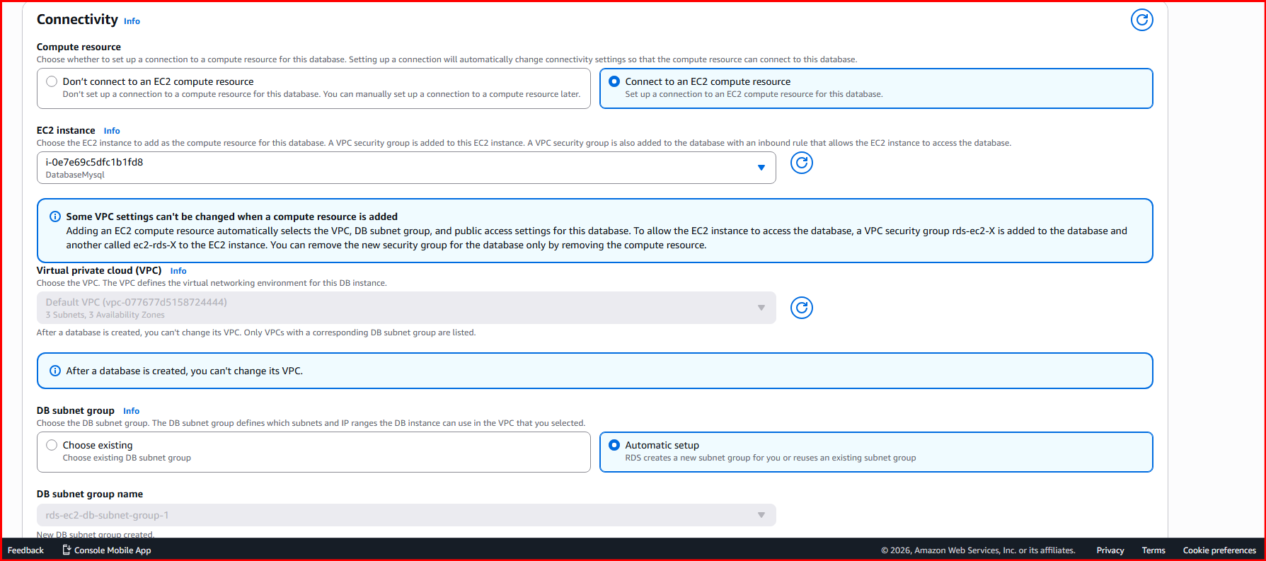

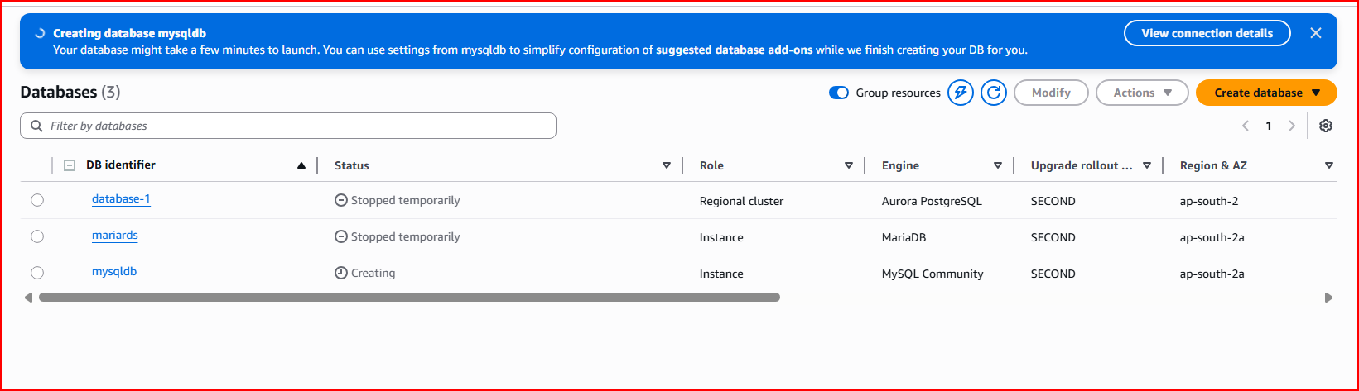
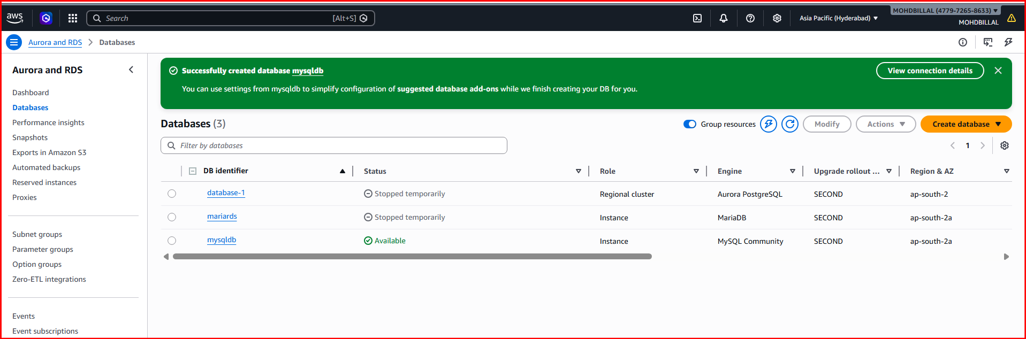

8. Configure Multi-AZ.

Step 1: Open RDS Console
Login to AWS → go to RDS → click Databases

Step 2: Select Your DB Instance
Choose your MySQL/MariaDB RDS instance

Step 3: Modify Database
Click Modify

Step 4: Enable Multi-AZ
- Find Availability & durability section
- Set Multi-AZ deployment → Enable

Step 5: Apply Changes
- Scroll down
- Choose:
  - Apply immediately (or during maintenance window)
- Click Modify DB instance

Step 6: Wait for Update
- Status → Modifying
- After completion → Available

Step 7: Verify Multi-AZ
- Open DB details
- Check:
  - Multi-AZ = Yes

How Multi-AZ Works
- AWS creates a standby instance in another Availability Zone
- Data is synchronously replicated
- Automatic failover happens if primary fails

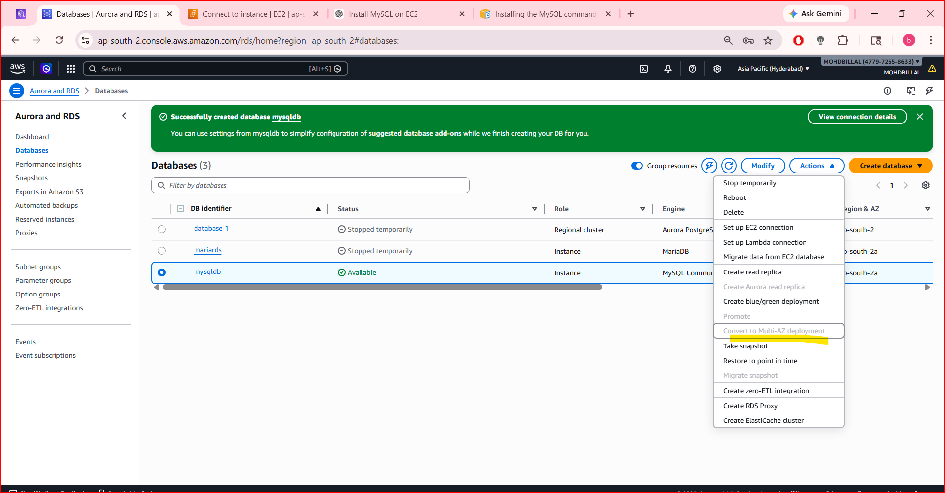

9. Take backup of DB and restore the DB.

Step 1:
Go to RDS → Databases → Select DB

Step 2:
Click Actions → Take snapshot

Step 3:
To restore → Go to Snapshots → Restore snapshot
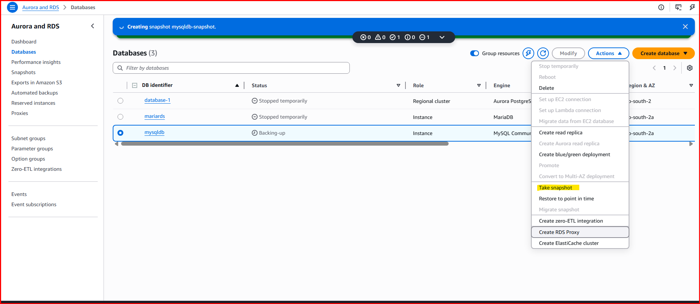
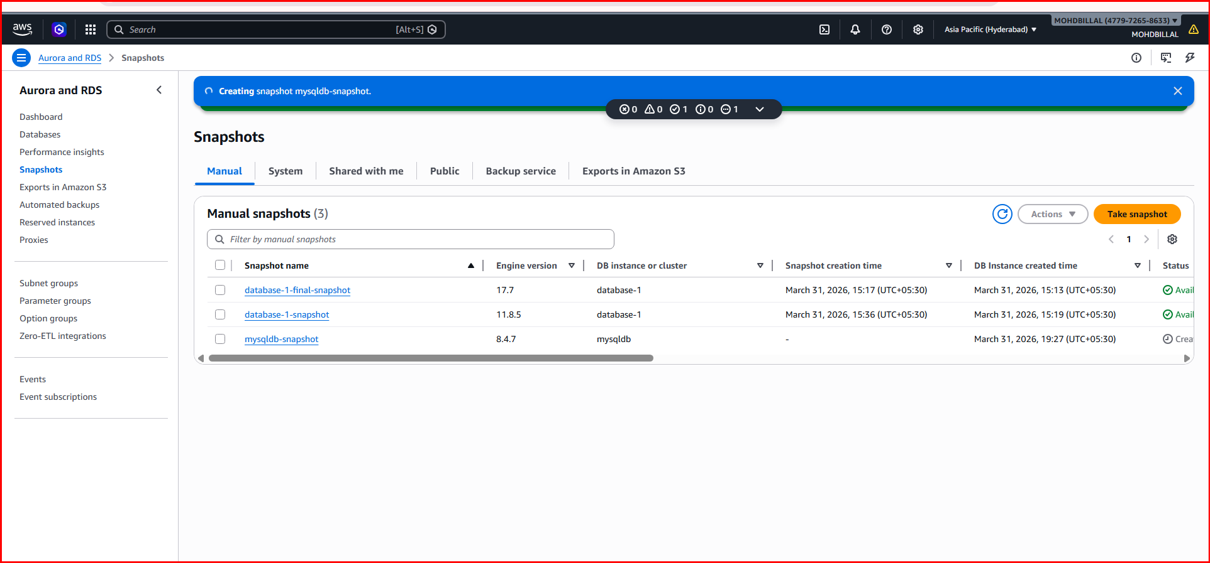
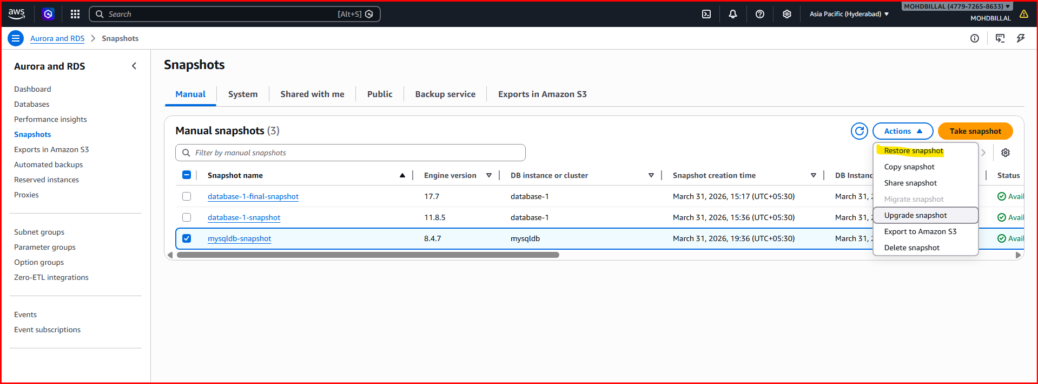

10. Create read replica.
Step 1: Navigate to Database instance and select the DB, we want to perform Read-replica.
